LEOPARD JUMPER CONFIGURATION for MCTK

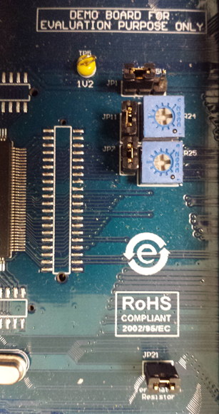

|  |  |
| --- | --- |
| JP1 | **3V3** |
| JP11 | **ON** |
| JP7 | **ON** |
| JP21 | **ON** |

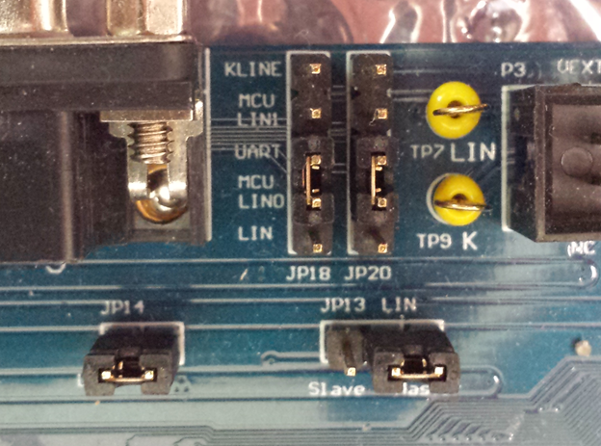

|  |  |
| --- | --- |
| JP18 | **UART/MCU LIN0 (RX)** |
| JP20 | **UART/MCU LIN0 (TX)** |
| JP14 | **ON** |
| JP13 | **LIN MASTER** |

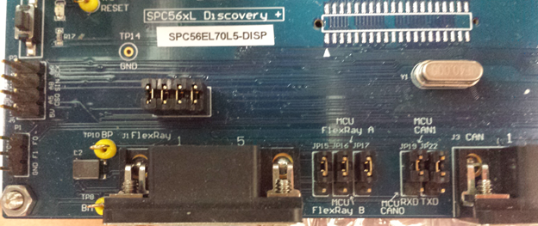

|  |  |
| --- | --- |
| JP15 | **1-2** |
| JP16 | **1-2** |
| JP17 | **1-2** |
| JP19 | **1-2** |
| JP22 | **1-2** |
| X5 | **ON** |

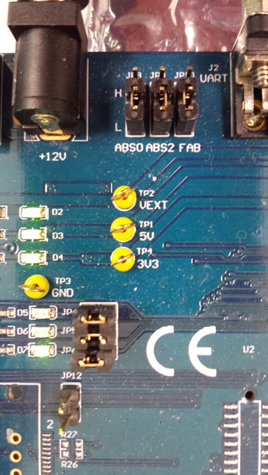

|  |  |
| --- | --- |
| JP8 | **L** |
| JP9 | **L** |
| JP10 | **L** |
| JP4 | **ON** |
| JP5 | **ON** |
| JP6 | **ON** |
| JP12 | **OFF** |